CIS 104 Midterm

Name:__________

*Open book and open note just not open friend… Cite all sources used. Submit solutions via email attachment.*

Essay: 10 Points each, minimum of a paragraph…

1. What is a type conversion? Give an example of where and how you would use a type conversion.
2. What is the difference between a function definition and a function call?
3. What will be the output of the following python code and why?

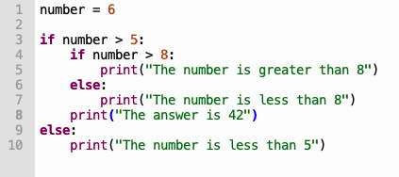

1. (25 Points) Create a program in python that will input a number from a user, call a function which passes that number, then counts by twos to that number on screen from the function. After the function returns thank the user. Draw a flowchart for the program, then implement the plan in code. Attach a copy of the flowchart, code, and a screenshot of the output to your exam submission. See below for sample output:

*Enter a number to count to:* 12

*2*

*4*

*6*

*8*

*10*

*12*

*Thanks for using the counting program!*